**Experiment 1:-**

Design a LED flasher.

**Circuit Diagram:-**

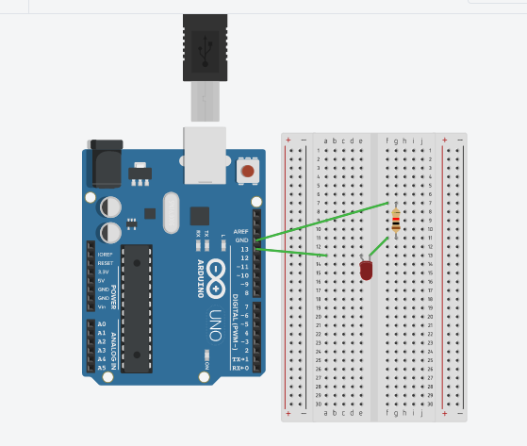

**Theory:-**

**Concepts used in this experiment:-**

The concepts used in performing this experiment-

* The arduino board can supply a power of 5V as digital output signals through 14 pins.
* The GND pin of the arduino board acts as ground.
* In the bread board the two rows present at the top and bottom, are connected with each other in series and the columns present in between are connected in a set of 5 each. The connection pattern is shown below: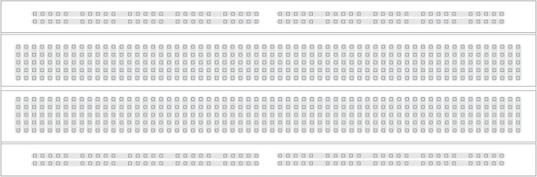

**Learnings and Observation:-**

* **Learnings:**
* I have learned how to work practically with a breadboard and other things.
* I have learned how an arduino works and how current flows.

**Observations:-**

* When we pass electrical signals through our code the LED glows.

**Problems and Troubleshooting:-**

The problems faced by me while doing this task are :-

* The LED which I used was not in a proper working condition.
* The circuit was not working because the wires were not connected properly.

**Precautions:-**

The precautions that should be taken while doing this experiment are:-

* The connections should not be loose.
* Every stuff should be joined at their appropriate place and it should be properly closed.
* The code should be written properly.

**Learning Outcomes:-**

* I have learned how to make circuits practically by using Arduino board.
* I have learned how all the hardwares should be connected to make them work in a proper condition.